RUSTAMJI INSTITUTE OF TECHNOLOGY

BSF ACADEMY, TEKANPUR

Synopsis Of Minor Project



**Submitted by**

Monu Yadav Nilesh Narwade Praaveer S Kaliyar Karan

(0902CS211031) (0902CS211034) (0902CS211038) (0902CS211027)

B.Tech. Computer Science Engineering 5th Semester (2021-2025 batch)

# Guided by

Yograj Sharma, assistant professor Department of Computer Science and Engineering

# OBJECTIVE

*The main objective of the Project on Online News Portal is to manage*

*the details of News, News Category, Latest News, Sports News, Weather News. It manages all the information about News, Comment, Weather News, News. The project is totally built at administrative end and thus only the administrator is guaranteed the access. The purpose of the project is to build an application program to reduce the manual work for managing the News, News Category, Comment, Latest News. It tracks all the details about the Latest News, Sports News, Weather News. The website will allow users to browse news articles by category, such as world, business, technology, and sports. Users will also be able to search for news articles by keyword. Each news article will display the headline, body text, publication date, and source. The website will also include a section for featured news articles, which will be updated regularly*.

# Introduction

*This project aims to develop a news website using HTML, CSS, JavaScript, and the News API. The website will allow users to browse news articles from a variety of sources, including major news organizations and popular blogs. Users will also be able to search for news articles by keyword and category.*

*The website will be designed to be user-friendly and informative. It will feature a clean and responsive layout, and it will be easy to navigate. The website will also include a variety of features, such as the ability to save favourite articles, share articles on social media, and receive notifications about breaking news.*

*This project access to a wide variety of news articles from a variety of sources.*

*It provides a user-friendly and informative way to browse and read news articles.*

# Problem statement

*The current news landscape is fragmented and overwhelming. There are many different news sources, each with their own unique perspective. This can make it difficult for users to find the news they need and to stay informed about current events.*

*In addition, many news websites are cluttered and difficult to navigate. This can make it difficult for users to find the news they are looking for and to read it in a way that is both informative and engaging.*

*This project aims to solve these problems by developing a news website that is:*

* *Comprehensive: The website will provide users with access to a wide variety of news articles from a variety of sources.*
* *User-friendly: The website will be easy to navigate and use.*
* *Informative: The website will provide users with the information they need to stay informed about current events.*
* *Engaging: The website will present the news in a way that is both informative and engaging.*

# SOLUTION STATEMENT

Our news website is different from other news website in terms of the solution provided by us. This website turns out to be a great solution for everyone who is interested in news and awareness. It categories different news articles so as make it easy for the people who want to read specific news related to their interest.

The proposed solution is to develop a news website using HTML, CSS, JavaScript, and the News API. The website will allow users to browse news articles by category, search for news articles by keyword, and read featured news articles. The website will also include a section for saved articles and a section for notifications.

The website will be designed to be responsive, so that it looks good and functions well on all devices, including desktops, laptops, tablets, and smartphones.

# TECHNICAL DETAILS

*NETWORK REQUIREMENT :-*

*For the website to run in a smooth manner a stable network connection is required****.*** *TECHNOLOGIES USED :-*

1. *HTML* ***-*** *HTML is a markup language for web pages. It uses tags to define the structure and content of the text. It is not a programming language, but a way of annotating text for browsers. HTML elements can have attributes and be nested. HTML has predefined tags and follows a standard syntax. HTML can be combined with CSS and JavaScript. HTML is essential for web development. In this website HTML is used for creating divisions for navigation bar and website body.*

1. *CSS - CSS is a language that styles HTML pages. It can modify colors, fonts, layouts, and more. CSS makes web pages more attractive and user-friendly. CSS is written in separate files or inside HTML tags. CSS can change the appearance of HTML elements, such as color, font, size, margin, border, background, and more. CSS can also create animations, transitions, transformations, and other effects. CSS is one of the core technologies of the web, along with HTML and JavaScript.*
2. *JAVASCRIPT - JavaScript is a language that makes web pages interactive. It can change the content, style, and behavior of web pages. It is easy to use and works with HTML.*

*JavaScript can run in browsers and servers. JavaScript can create dynamic and responsive web applications. JavaScript can manipulate the Document Object Model (DOM)and the Browser Object Model (BOM).*

1. *NEWS API – News API is an important part of our website. News API is a service that allows you to access news articles and headlines from various sources around the world. You can use News API to search for news by.*
2. *keywords, dates, publishers, languages, and more.*
3. *You can also get live breaking news and historical news data in JSON or Excel formats. News API is useful for developers, researchers, journalists, and anyone who wants to stay updated with the latest news and trends.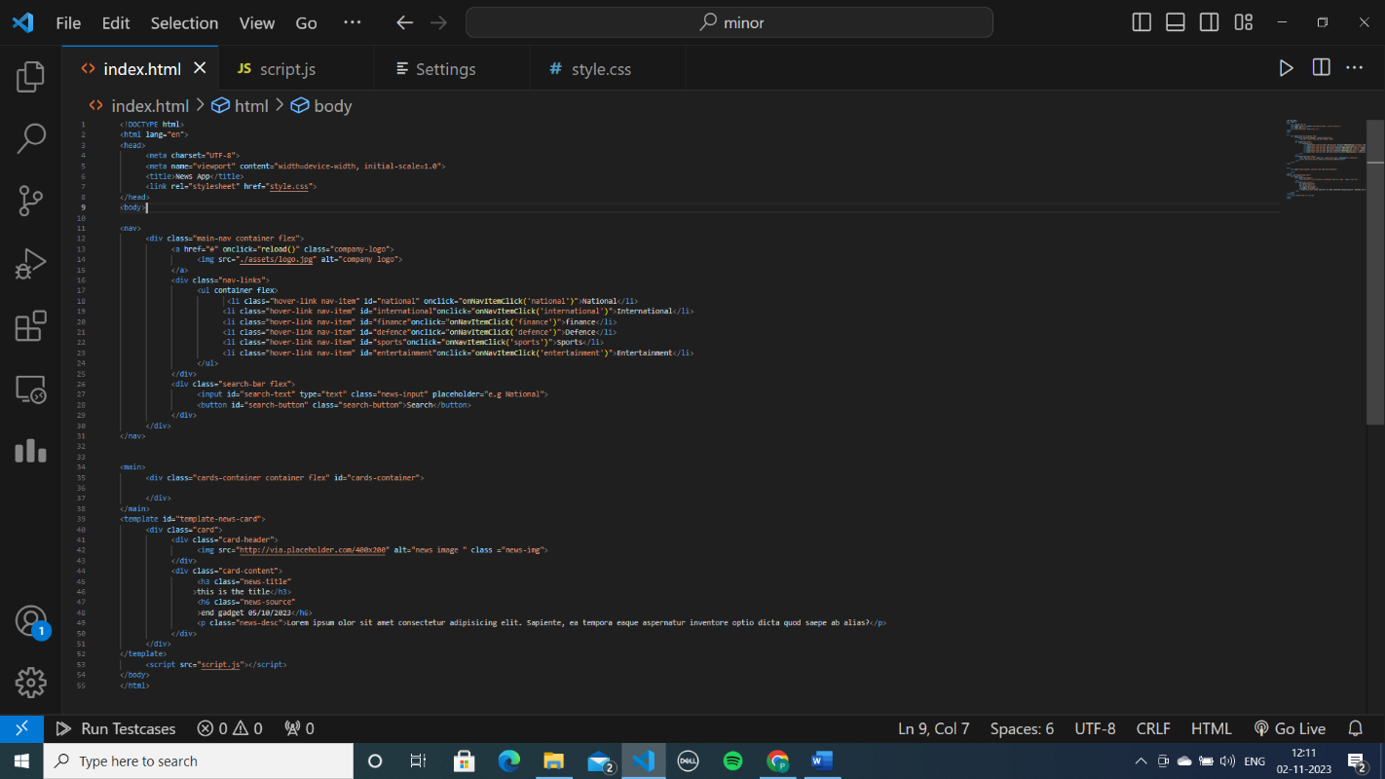*

*HTML CODE SS*

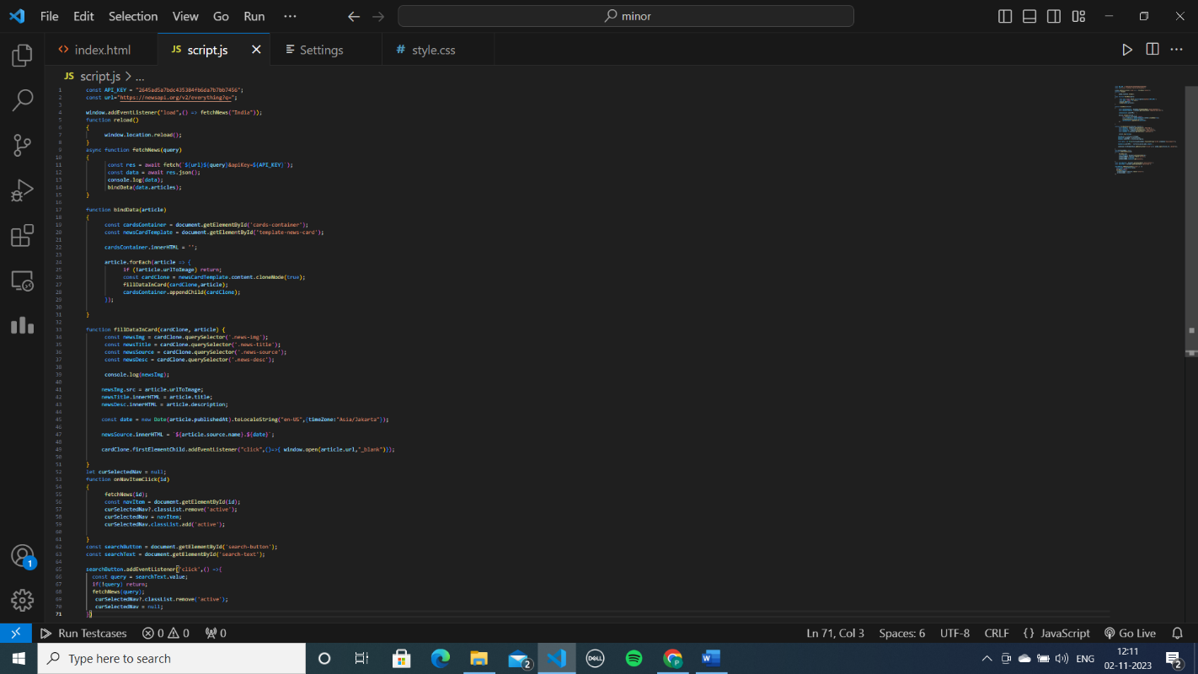

*JAVASCRIPT CODE SS*

*CSS CODE SS:*

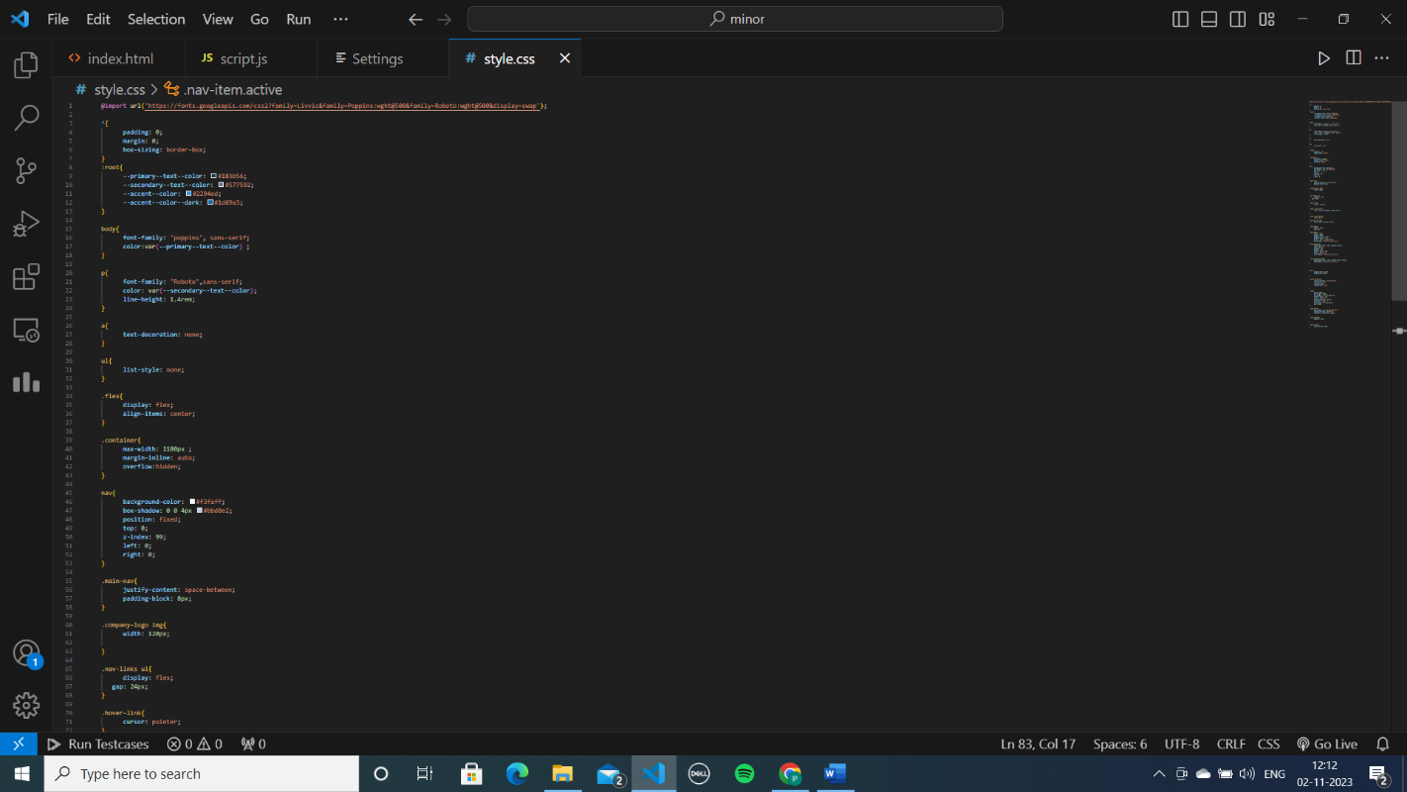

*WEBSITE SS:*

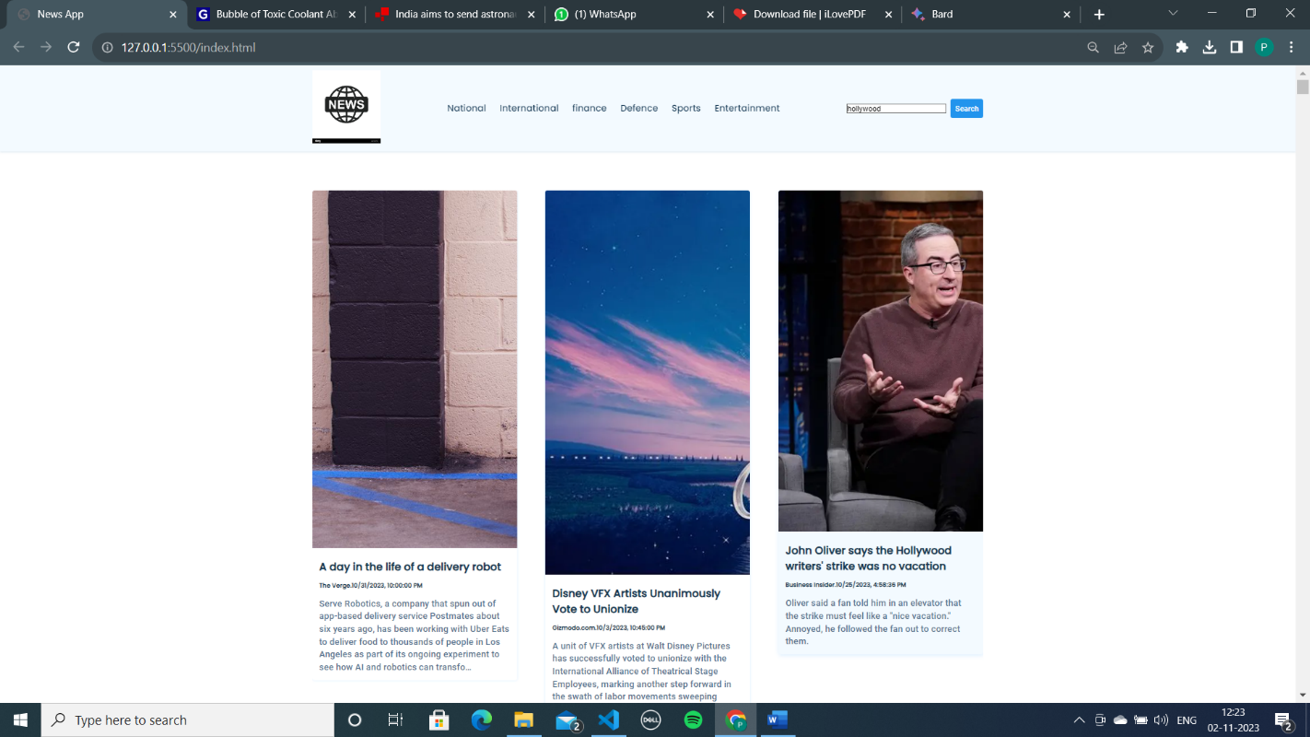

## INNOVATIVENESS AND USEFULNESS

***Innovativeness*** *generally refers to the ability to create, introduce, or apply new ideas, processes, products, or procedures. On the other hand,* ***usefulness*** *refers to the degree to which something can be used for its intended purpose or in general, to fulfill a need or solve a problem. It is about practicality and functionality. In the context of products or services, innovativeness can make them stand out in the market, while their usefulness determines how well they meet the needs of the users. In this website we have used the different technologies discussed above in an innovative and useful way along with our creative thoughts. News Api is also used in an innovative manner in the website. News API is a powerful tool for businesses, researchers, and*

*developers alike. It provides a simple yet powerful way to access a vast amount of news data from around the world. Whether you are tracking your brand’s media coverage, analyzing trends, or building a news aggregation service, News API has you covered.*

Innovative:

* The website will use a single-page application (SPA) architecture. This will make the website more responsive and faster loading.
* The website will use the News API to fetch news articles from a variety of sources. This will allow the website to provide users with a more comprehensive and impartial view of the news.
* The website will use a variety of security measures to protect users' data. This includes using HTTPS, a Content Security Policy (CSP), and Cross-Site Scripting (XSS) prevention.

Useful:

* The website will provide users with a one-stop shop for news from a variety of sources. This will save users time and effort.
* The website will be easy to use and navigate. This will make it accessible to users of all ages and skill levels.
* The website will provide users with a variety of features, such as the ability to save favourite articles, share articles on social media, and receive notifications about breaking news.

In addition to the above, the proposed news website project can also be useful in the following ways:

* Personalized news experience: The website can be personalized to provide users with news that is relevant to their interests. This can be done by allowing users to select their preferred categories and sources.
* Multilingual support: The website can be translated into multiple languages to make it accessible to users from all over the world.
* Accessibility: The website can be made accessible to users with disabilities by following accessibility guidelines.

Overall, the proposed news website project is a valuable and innovative project that can be useful to a wide range of users.

## CONCLUSION

*This website is useful for the users who want to read news related to their personal interest only. This website will provide you categorized news article so you*

*do not need to check or surf other websites for different news articles. You are just one click away to shift to other news article in a different category. Moreover, it is a user-friendly website with a interactive and efficient interface.*

## Bibliography

***All the reference data is taken from :-*** [*https://www.wikipedia.org/*](https://www.wikipedia.org/)[*https://www.tutorialspoint.com/index.htm*](https://www.tutorialspoint.com/index.htm) [*https://www.w3schools.com/*](https://www.w3schools.com/)

[*https://www.google.com/*](https://www.google.com/)

[*https://newsapi.org/*](https://newsapi.org/)